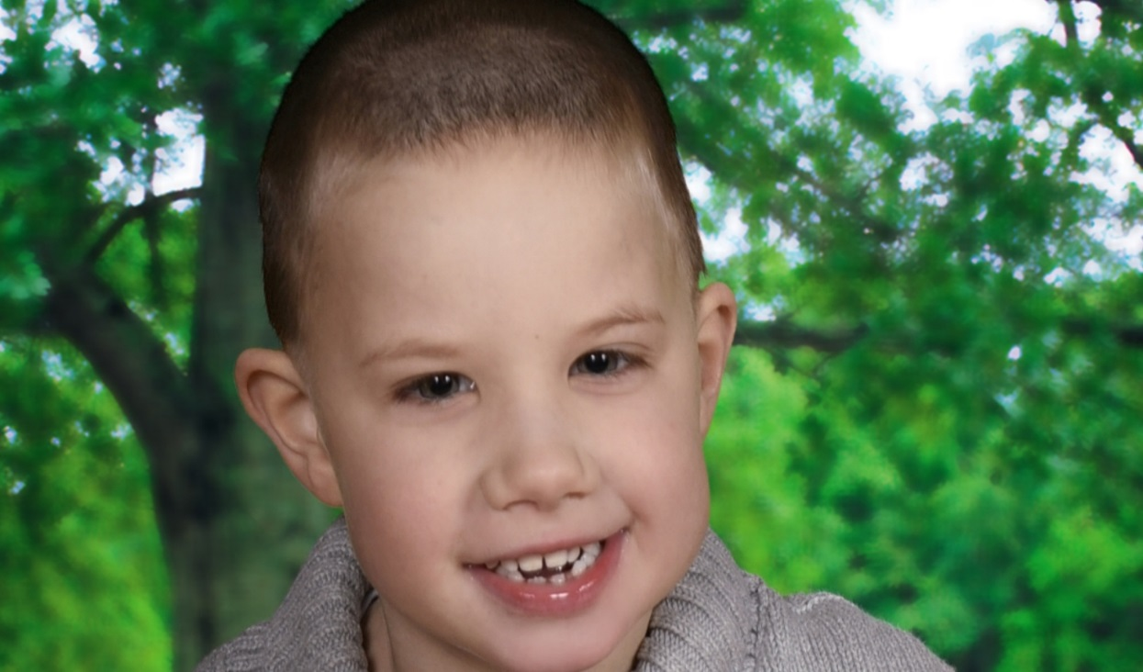
Hypoplasia of the Corpus Callosum (HCC)

Jake Connolly

Jake is developmentally delayed. He is nonverbal and has low muslce tone. Jake has a difficult time with gross motor, fine motor, and social skills.

Jake is usually very happy. He is pretty predictable once you get to know him. Jake has a lot of sensory needs.

He loves and is calmed by You Tube videos, such Little Baby Bum nursery rhyme videos. Favorite things are the iPad, videos, puzzles, & wheels.
The Corpus Callosum is the bundle of fibers or main pathway that connects the left and right sides of the brain and enables them to communicate with each other. In Jakes’s case, the Corpus Callosum is present, but it is very thin. It is undetermined what caused Jake’s HCC, it is a rare congenital brain abnormality of which there is no cure. It does not limit potential.
Without a fully formed Corpus Callosum, Jake faces added challenges and difficulties. Enclosed is a packet of information that we hope you find helpful regarding Disorders of the Corpus Callosum (DCC). Thank you for taking the time to review, while you help Jake navigate on his important journey.

ROUTINE

He thrives with routines. He can have meltdowns if things do not go his way. His meltdowns are short lived.

REPeTITION

It takes lots of repeating to learn a new skill. Repetition, repetition, repetition is key to making connections for Jake.
akes lots of repeating to learn a new skill and he can even “forget” after he’s learned it. 2

ROUTINE
Thrives with routine, especially in school. He can have meltdowns if things don’t go his way.

3

2

2
3

3
1

REPeTITION
It takes lots of repeating to learn a new skill and he can even “forget” after he’s learned it.

1

MultI -Presentation
It helps if information is presented in a variety of ways to help Jake find a way to relate to and learn new material.

