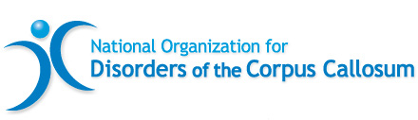
NODCC Corporate Office
PMB 363 18032-C Lemon Drive
Yorba Linda, California 92886
Information & Helpline 714-747-0063
Email info@nodcc.org www.nodcc.org
EIN 33-10293

Calling for Volunteers! We need your help!

We need volunteers to help execute and run a smooth conference weekend at the 2024 Disorders of the Corpus Callosum Conference to be held June 27 – June 30 at the Marriott Chicago O'Hare.

Shifts can be as short as four hours or a full day.
Lunch will be provided to those volunteering for a full day (8-10 hours).
Volunteers must be aged 18+ and will be required to sign a liability release.

We need help in the following areas:

Information Center and Store
Register attendees, sell merchandise, answer attendee questions
Silent Auction
Watch gifts on tables, and assist as a runner at auction closing
Greeters and Runners
Serve in a variety of capacities as needed
Photography
We are seeking people with special talent in taking photos
Technology
We are seeking people with technical experience to work in the lecture rooms ensuring
computers, projectors, microphones, slide shows, etc. are functioning properly

Contact conference@nodcc.org if you are interested in volunteering.

Our heartfelt thanks! The gift of your time working at this conference is greatly appreciated!

Please know your volunteerism will make a difference in the lives of many grateful families.

Click below to download the letter and form:

2024 Conference – Volunteer Form

Click button below to register online:

