DCC & Child’ Name



Written & illustrated by

Author 1
&
Author 2

Hi! I’m Child’s Name.
I am 10 years old, and I have blonde hair and blue eyes.

I love chocolate and rollercoasters.

I live with my mommy, daddy, twin sister Eliana and cats Ripley & Rosie. We have lots of fun together.
My family loves the water and sea life.
I have trouble doing some of the things that other 10 year olds do because I have DCC.

WHAT IS DCC?

DCC stands for dysgenesis of the corpus callosum.
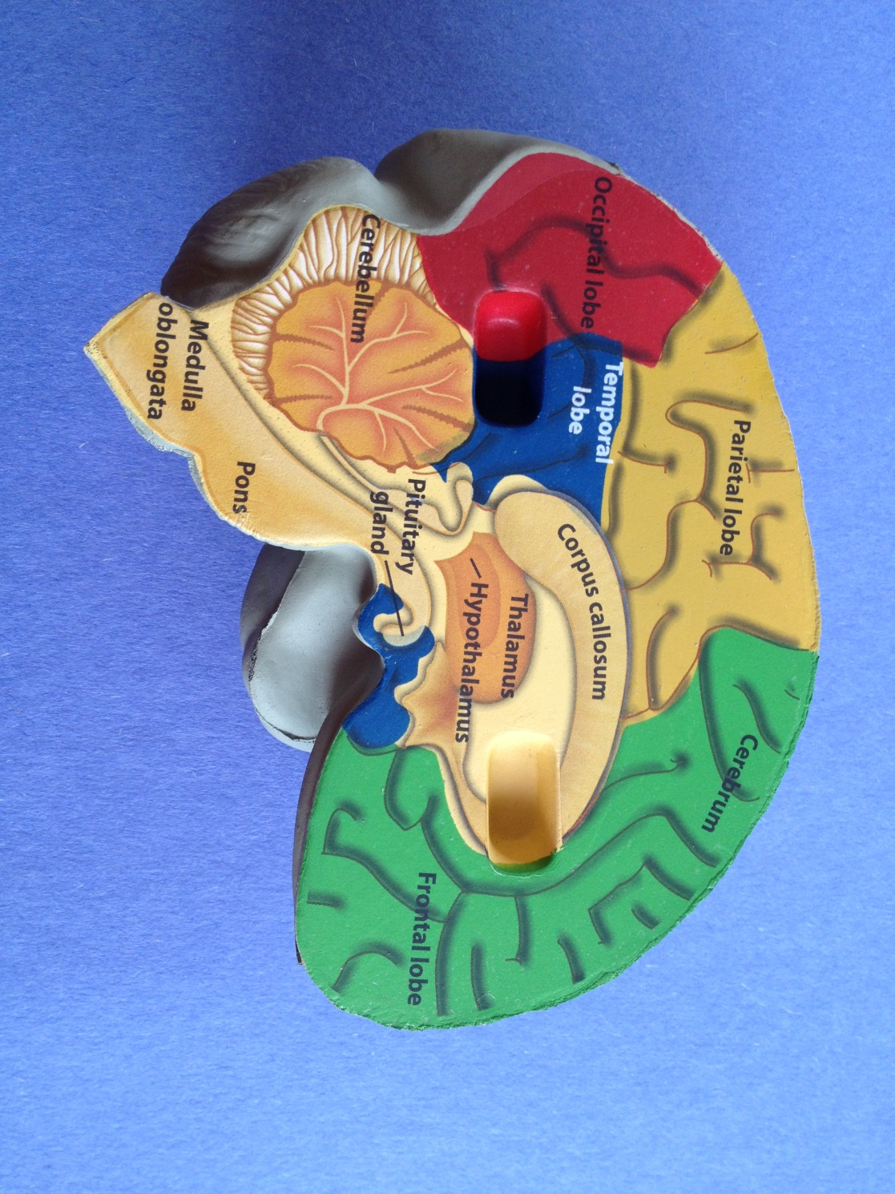
The corpus callosum is a part of the brain. It is made of MILLIONS of nerve fibers. The corpus callosum connects the right and left sides of the brain and helps them to communicate.

The two halves of the brain are like two cities separated by a river. The nerve fibers of the corpus callosum are the bridges that connect the two cities.
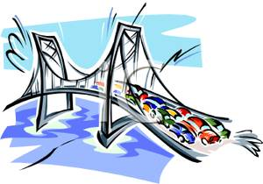

Thoughts and ideas use those bridges like cars and trucks to go back and forth.

I have DCC so that means that part of my corpus callosum is missing.

This is a picture of my brain showing my corpus callosum in the middle.

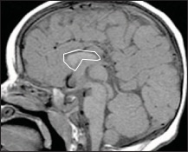
I don’t have MILLIONS of nerve fibers connecting the two sides of my brain.
Thinking can be hard work for me. Where you have superhighways in your brain, I have some dead ends and back roads.

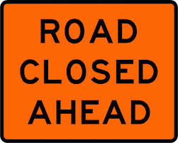 | 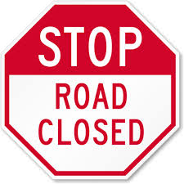

Sometimes my thoughts get caught in a huge traffic jam and I have trouble doing things that are easy for you to do.

Sometimes when I wake up in the morning, I am able to do something that I was not able to do when I went to bed.

During the night, a connection was made in my brain.
I love coming to school each day and seeing my friends. But learning new things can be very hard for me.

Things that are easy for you to learn, are hard for me to learn.

Things that are hard for you to learn, like reading, will be even harder for me to learn.

Teachers have to have a lot of patience with me.
Having DCC has given me weak muscle tone. This means that it took me a long time to be able to sit up, crawl, and walk. That is why I wear braces on my feet to help me walk straight.
It also means that it is hard for me to put together sounds into words and talk. I have 10 words and am working on more. I use my Ipad and sign language to help me communicate.
I can say: Yes  No  Go  Gain (for “again”)  Ipa (for IPad)  Arm  Help  Ball  Op (open) | I use sign language to say:  All done Music  More Thank you
To help me get stronger, my parents built a therapy room in our basement that looks like a pirate ship. It has a trampoline, swings, slides, a climbing wall, sand box and ball pit.
Playing in the basement is really fun!
Things are hard for me but I keep trying. Until I was 4 years old, I needed the help of a walker to walk but now I am able to jump and to run around and play on the playground at school. I like playing on swings and slides the best.

Some things, like math, will always be hard for me.
But there are a lot of things that I can do.

I like to go bowling.

I ride a special bicycle that let’s me use my hands and feet to pedal.

I ride horses at the Cincinnati Therapeutic Riding and Horsemanship Center.

I go to baseball games with my daddy and watch the Reds play. I like it when they play the baseball song and love watching fireworks after the game.

I had so much fun snow tubing at Perfect North.

Last summer my family vacationed in Jamaica. I loved swimming in the pool and the ocean but my favorite thing was going down the water slide.

Last year, I won a gold medal in the Hamilton County Special Olympics for throwing.
This morning my mommy said “You work so hard to do the things that you do. You always keep trying.”

“And now we can have more fun playing together,” added my sister Eliana.

My daddy said, “I can’t wait to see what you will be able to do next. You are amazing!
I said, “That’s because..
I’m Olam.
And I have DCC.

